Quizora App Documentation
The Quizora application is a user-friendly quiz platform designed to help users learn, play, and improve through quick, 5-minute challenges. It features an intuitive interface with options to pick different categories, answer questions, and save progress using smart review cards. The app also supports offline use and adapts smoothly to various screen sizes for a seamless experience.
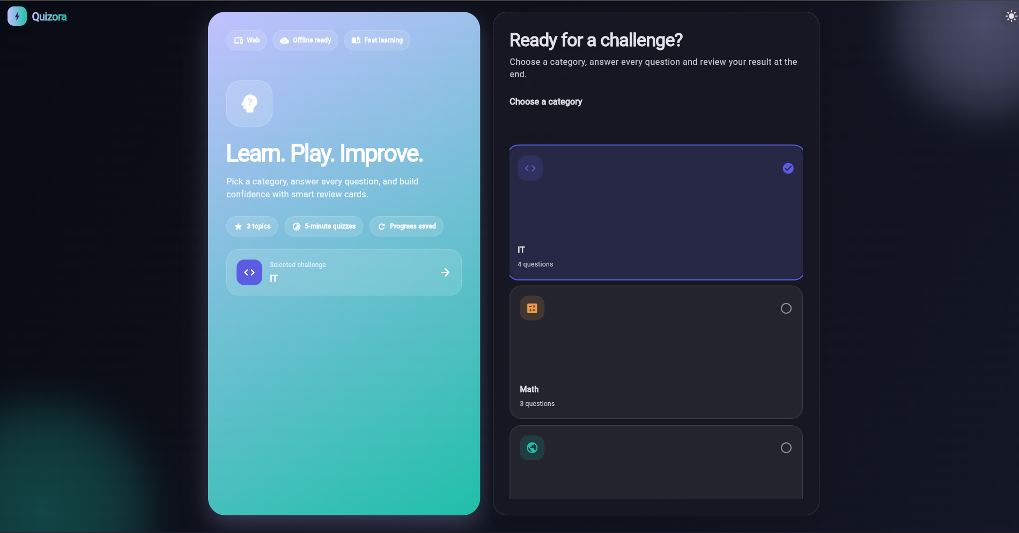
Figure (1.0)
The Screenshot above Analysis presents the UI of a quiz app. Modern rectangular cards dominate the screen, drawing the eye to the large blue-green panel on the left. The panel proclaims the app’s value proposition: “Learn. Play. Improve,” while shorter tags identify the main features – “3 topics,” “5-minute quizzes” and “Progress saved.” Contrasting with the bright left panel, the right side of the UI utilizes dark background and asks “Ready for a challenge?” In conjunction with the panel on the left, the card on the right engages the user by offering a choice of categories with “IT” selected by default. Overall, the app UI appears user-friendly and intuitive. Rounded corners, short lines and the presence of a “Start” button invite interaction.
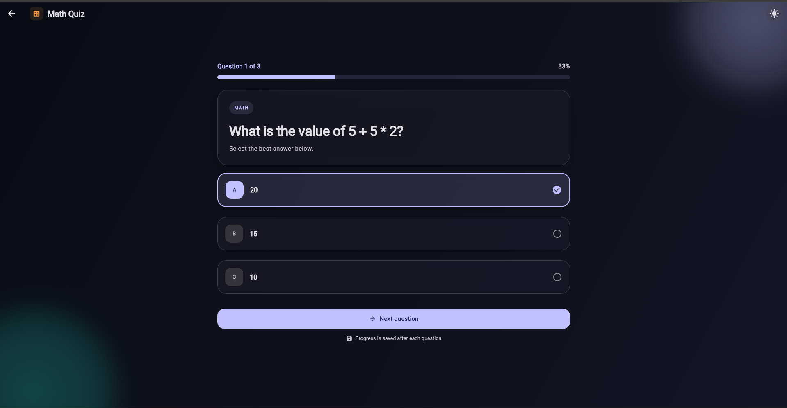
Figure (1.1)
This presents a dark interface of a quiz application, with a bar at the top indicating that it is the “Math Quiz” and showing the progress of the user on the 1 out of 3 questions with 33% completion. Below the bar, there is a card stating the question: “What is the value of 5 + 5 2?” with three answer options provided, with the “A 20” option selected. At the bottom of the card, there is a “Next question” button, while the overall design is organized in a friendly manner and uses simple colors and rounded corners.
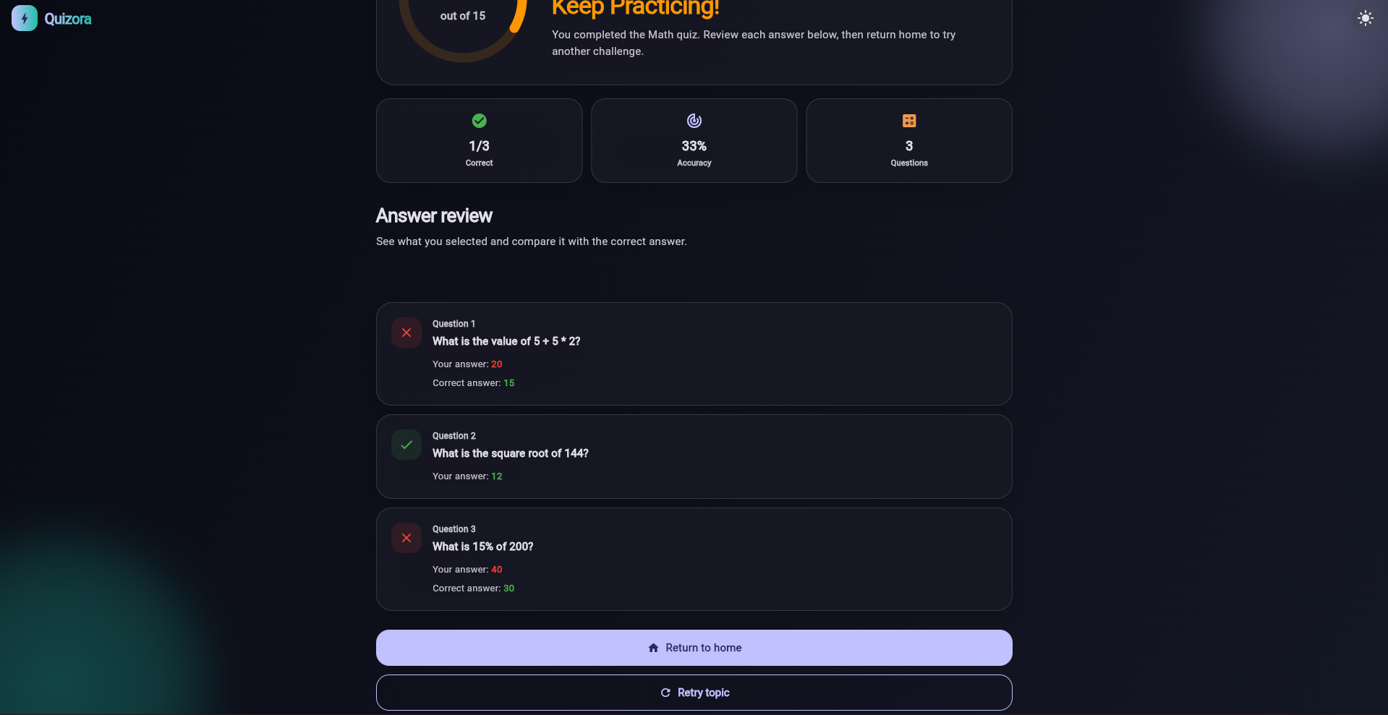
Figure (1.2)
The screenshot demonstrates the screen with the results of the quiz. Cards on the screen suggest that the task was a Mathematics quiz, where the user saw his results after finishing the task. The first card illustrates the number of correct answers, accuracy, and the total number of tasks. On the second card, there are the tasks, their answers, and the answers provided by the user. Additionally, there is a button to return to the previous screen or try the topic again.
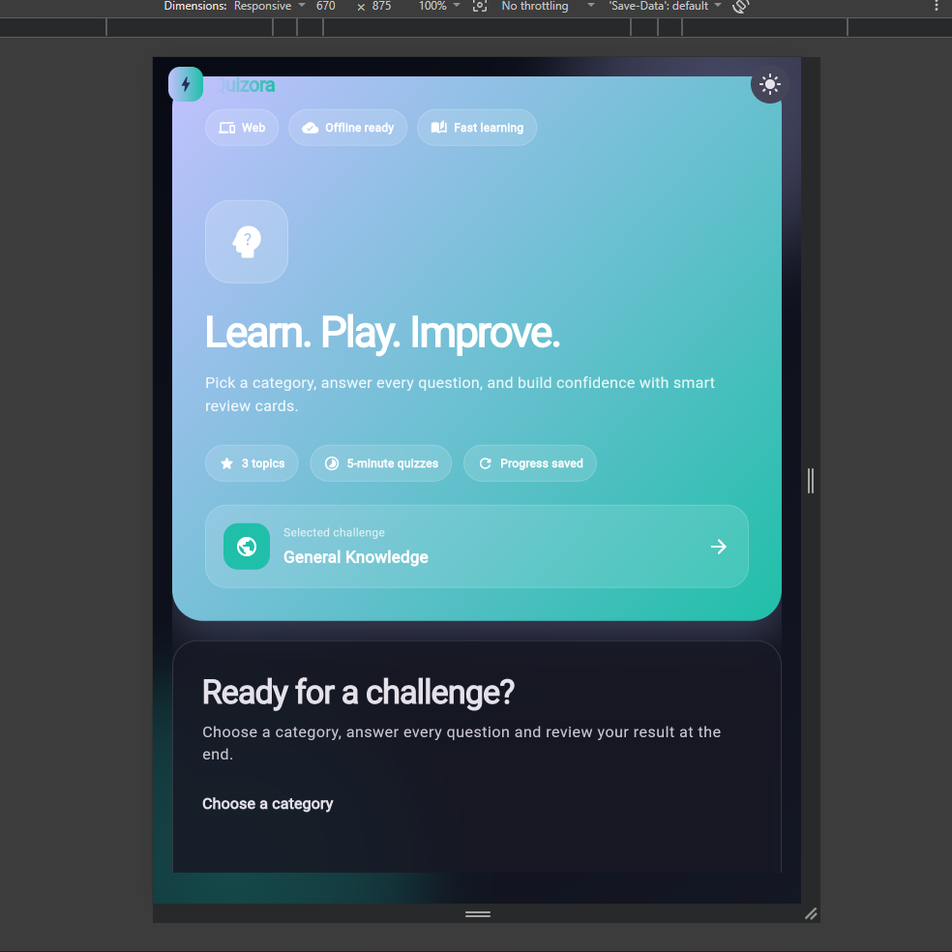
Figure (1.3)
This responsive design view demonstrates how the application can adapt to a smaller screen by shifting from a horizontal to a vertical layout and thereby, placing the blue hero panel on top of the dark quiz panel. The interface maintains the ample spacing between the buttons and large text size for better readability and accessibility on a smaller scale while reducing the overall width and keeping the same pattern of the brand.

